“ASSESSING THE ROLE OF TOURISM IN PROMOTING ECONOMIC DEVELOPMENT IN MATTANCHERRY: A CASE STUDY APPROACH”
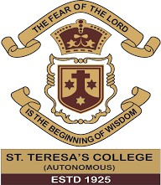
A major project submitted in partial fulfillment on the requirement for the Award of PG of Integrated MA in economics

Submitted by
AXY ANTONY
Reg. No: AMI20ECO002
Under the guidance of
Dr. ANOOP FRANCIS
CHAIRMAN OF KOCHI CULTURAL
HERITAGE AND TOURISM SOCIETY

INTEGRATED M.A PROGRAMME IN SOCIAL SCIENCE- ECONOMICS
DEPARTMENT OF ECONOMICS AND CENTER FOR RESEARCH
ST. TERESA’S COLLEGE (AUTONOMOUS)
ERNAKULAM
(Affiliated to Mahatma Gandhi University, Kottayam)
August 2025

CERTIFICATE
This is to certify that the project titled “ASSESSING THE ROLE OF TOURISM IN PROMOTING ECONOMIC DEVELOPMENT IN MATTANCHERRY: A CASE STUDY APPROACH”, submitted in partial fulfillment of the requirement for postgraduation of Integrated M.A program in Social Science-Economics to St. Teresa’s college, Ernakulam (Autonomous) (Affiliated to Mahatma Gandhi University, Kottayam) is a bona fide record of the work carried out by AXY ANTONYunder my supervision and guidance.

Head of the department Guide and supervisor
Dr. ANUPA JACOB Dr. ANOOP FRANCIS

ACKNOWLEDGEMENT

First, we thank God almighty for the blessing showered throughout this thesis. Without his blessings and grace, the thesis would not have been possible.
I am extremely thankful to my guide Dr. ANOOP FRANCIS, Chairman of Kochi Cultural Heritage and Tourism Society, for his extraordinary guidance and mentorship throughout every phase of the project and his stimulating ideas and constant encouragement bring this thesis to fruition.
It would not have been able to collect data without the cooperation of the displaced fishing community. They generously spend their valuable time for sharing information. Thank you to all the respondents for opening their minds to share their life story without any hesitation.
We would like to express our gratitude to our parents and family members for supporting us, giving information about the displaced community, from the time we took up this research until its successful completion
Finally, we take this opportunity to thank one and all who helped us directly and indirectly in the successful completion of the thesis.
AXY ANTONY

DECLARATION

We hereby declare that the project titled “ASSESSING THE ROLE OF TOURISM IN PROMOTING ECONOMIC DEVELOPMENT IN MATTANCHERRY: A CASE STUDY APPROACH” submitted by me for partial fulfillment of the requirement for postgraduation of Integrated M.A program in Social Science- Economics in original work.

Signature of the supervisor Signature of the candidate
Dr. Anoop Francis Axy Antony

CONTENTS
Chapter  No | Particulars | Page  No
I | INTRODUCTION | 9-13
II | REVIEW OF LITERATURE | 14-17
III | RESEARCH METHODOLOGY | 18-21
IV | DATA ANALYSIS AND INTERPRETATION | 22-38
V | SUMMARY OF FINDINGS AND DISCUSSION | 39-41
 | Bibliography | 48

LIST OF TABLES
Table  No | Particulars | Page  No
4.1 | Ownership type classification of your business
4.2 | Type of tourist’s wise classification
4.3 | Classification based on percentage of income is generated from tourists
4.4 | Classification based on collaboration interest with tourism agencies
4.5 | Classification based on staff members are currently employed
4.6 | Classification based on the type of business
4.7 | Classification based on the extension of business in tourist areas
4.8 | Classification based on the trends
4.9 | Classification based on the tourism challenges

LIST OF CHARTS
Chart  No | particulars | Page  No
4.1 | What is the ownership type of your business?
4.2 | Which type of tourists do you mostly cater to?
4.3 | Has your revenue increased due to tourism?
4.4 | What percentage of income is generated from tourists?
4.5 | Are you interested in collaborating with tourism agencies?
4.6 | How many staff members are currently employed?
4.7 | What type of business do you operate?
4.8 | Would you expand your business if tourism increases?
4.9 | Is your business affected by tourist trends (e.g., global events)?
4.10 | What is your biggest challenge related to tourism?
4.11 | What kind of government support do you expect?
4.12 | What is your biggest challenge related to tourism?
4.13 | Do you receive any support from the tourism department?
4.14 | What type of business do you operate?

LIST OF FIGURES
Figure  No | Particulars | Page  No
4.1 | Lists the business ownership categories | 26
4.2 | Highlights how much of local businesses’ revenue depends on tourism | 27
4.3 | How open businesses/individuals are to forming partnerships with tourism agencies. | 28
4.4 | Challenges faced with the type of government support expected. | 29
4.5 | Overall interest level of businesses/individuals in forming partnerships with tourism agencies. | 30
4.6 | Different staff size ranges given by respondents | 30
4.7 | This categorizes responses by whether businesses are affected by  global tourist trends | 31
4.8 | Different challenges respondents | 31
4.9 | Responses collected for whether individuals | 32
5.1 | Lorenz curve and Gini ratio of health expenditure during pre and post displacement | 34

CHAPTER I

INTRODUCTION

“ASSESSING THE ROLE OF TOURISM IN PROMOTING ECONOMIC DEVELOPMENT IN MATTANCHERRY: A CASE STUDY APPROACH”

CHAPTER I

INTRODUCTION
Tourism today is one of the most dynamic and rapidly expanding sectors of the global economy. Beyond being a recreational activity, it serves as a powerful catalyst for cultural exchange, regional development, and economic progress. For many destinations worldwide, tourism plays a crucial role in job creation, income generation, infrastructure expansion, and entrepreneurship promotion.
In the Indian context, Kerala — widely celebrated as “God’s Own Country” — has gained prominence as a leading tourism hub owing to its scenic landscapes, cultural richness, and heritage attractions. Within Kerala, Mattancherry, situated in the heart of Kochi, stands out as a culturally significant location that reflects a blend of diverse communities, traditions, and architectural influences. Known for its spice markets, colonial-era structures, synagogues, churches, and palaces, Mattancherry has evolved into a popular heritage and cultural tourism destination, attracting both domestic and international visitors.
The growth of tourism in Mattancherry has directly supported livelihood opportunities, particularly in handicrafts, hospitality, food services, and small-scale businesses. It also contributes indirectly through traditional art performances, handicraft production, transport services, and souvenir markets. Importantly, tourism strengthens entrepreneurship and encourages the preservation of cultural heritage, thereby becoming an essential pillar of sustainable local development.
This study adopts a case study approach to analyze how tourism contributes to the economic development of Mattancherry, with particular attention to employment generation, income creation, infrastructure growth, and cultural preservation. It also examines the role of government policies, private sector participation, and community involvement in shaping tourism’s contribution to economic progress.

Displacement and Tourism Pressures
While tourism brings economic opportunities, it also generates social and cultural challenges, notably displacement. In Mattancherry, displacement may occur when local residents, traditional businesses, or cultural practices are forced out due to rising property values, commercial demand, and tourism-related development pressures.
As tourism expands, long-standing residents and small traders often face higher rents and living costs, leading to relocation. This process disrupts community networks, local traditions, and the authentic cultural fabric that makes Mattancherry attractive to tourists in the first place. Displacement can also take a cultural form, where heritage livelihoods such as spice trading, fishing, and handicrafts are replaced with souvenir shops, boutique hotels, and cafés. While these changes generate new revenue, they can weaken Mattancherry’s original identity over time.
Addressing this challenge requires sustainable tourism strategies that balance growth with community well-being — such as affordable housing policies, protection of local businesses, and ensuring resident participation in tourism planning.

Statement of the Problem
Tourism is recognized globally as a driver of economic development, capable of generating jobs, enhancing infrastructure, and safeguarding cultural heritage. In Kerala, locations such as Munnar, Alappuzha, and Fort Kochi have received considerable academic and policy attention regarding tourism’s role in development.
However, Mattancherry — despite its historical and cultural significance — remains underexplored in tourism research. The absence of focused studies has limited localized policy insights and targeted development strategies. While tourism in Mattancherry has the potential to create income, business opportunities, and cultural preservation, it also brings challenges such as rising living expenses, displacement, and dependency on seasonal visitors.
Without area-specific research, policymakers and community stakeholders struggle to design sustainable practices that balance economic benefits with social welfare. This study aims to address that gap by undertaking a comprehensive case study of Mattancherry, highlighting both the benefits and the risks of tourism.

Research Gap
Although Kerala’s tourism economy has been studied extensively, most research has centered on popular destinations such as Munnar, Alappuzha, and Fort Kochi. Mattancherry, despite being a multicultural heritage hub, has not been adequately examined as an independent case. Existing studies often provide generalized insights for Kochi as a whole, overlooking micro-level socio-economic aspects like income patterns, entrepreneurship, cultural preservation, and displacement specific to Mattancherry.
Additionally, there is a lack of integrated studies combining both quantitative indicators (income, employment, infrastructure) and qualitative perspectives (community experiences, cultural shifts). This research fills the gap by focusing exclusively on Mattancherry, analyzing tourism’s economic, social, and cultural dimensions, and generating localized recommendations for sustainable tourism policy.

Objectives of the Study
The primary objective is to evaluate the role of tourism in fostering economic development in Mattancherry through a case study approach.
Specific objectives:
- To analyze how tourism contributes to income generation and employment.
- To examine its impact on entrepreneurship, small businesses, and allied sectors.
- To assess the role of tourism in cultural and heritage preservation.
- To evaluate the infrastructure improvements and public services influenced by tourism growth.

Hypotheses
Economic Impact
- H₀: Tourism has no significant impact on income generation in Mattancherry.
- H₁: Tourism significantly contributes to income generation in Mattancherry.
Employment Generation
- H₀: Tourism does not significantly affect employment opportunities for local residents.
- H₁: Tourism significantly increases employment opportunities for local residents.
Cultural Preservation
- H₀: Tourism has no significant role in preserving Mattancherry’s cultural heritage.
- H₁: Tourism plays a significant role in preserving Mattancherry’s cultural heritage.
Infrastructure Development
- H₀: Tourism has no significant impact on infrastructure in Mattancherry.
- H₁: Tourism significantly contributes to infrastructure development in Mattancherry.

Research Questions
- How does tourism contribute to income generation for residents?
- What employment opportunities has tourism created?
- How has tourism influenced entrepreneurship and small businesses?
- In what ways has tourism promoted the preservation of culture and heritage?
- What infrastructure developments are linked to tourism growth?
- What challenges (e.g., displacement, rising costs) are faced by locals?
- How do government policies affect tourism development?
- What is the role of community participation in sustainable growth?
- How can tourism in Mattancherry be made inclusive and beneficial for all?

Limitations of the Study
- Geographic Scope – confined to Mattancherry, findings may not generalize to other regions.
- Sample Size – limited due to time/resource constraints, may not represent all stakeholders.
- Time Frame – short data collection period, seasonal variations may not be fully captured.
- Self-Reported Data – responses may involve personal bias or recall issues.
- Economic Data Availability – lack of detailed official data for Mattancherry.
- External Influences – global crises (e.g., pandemics, political shifts) not directly studied.
- Focus – emphasis is on economic impacts; social/cultural effects are secondary.

Chapter Scheme
- Chapter I – Introduction (Background, Research Gap, Problem, Objectives, Hypotheses, Scope, Limitations)
- Chapter II – Review of Literature (Theoretical Background, Kerala Tourism Studies, Socio-economic Impacts, Identified Gaps)
- Chapter III – Research Methodology (Case Study Design, Profile of Mattancherry, Sampling, Data Collection, Analysis Methods, Ethics)
- Chapter IV – Data Analysis and Interpretation (Demographics, Income/Employment, Entrepreneurship, Cultural Heritage, Infrastructure, Challenges, Hypothesis Testing)
- Chapter V – Findings and Suggestions (Key Results, Implications, Recommendations for Sustainable Tourism)
- Chapter VI – Conclusion (Summary, Limitations, Future Research)
- References – Books, Journals, Reports, Online Sources
- Appendices – Questionnaire

CHAPTER II

REVIEW OF LITERATURE

CHAPTER II

REVIEW OF LITERATURE
Tourism is widely recognized as a catalyst for regional economic growth, particularly in areas endowed with cultural richness and natural attractions. Academic discussions in this field cover multiple dimensions such as economic development, cultural preservation, community participation, infrastructure expansion, and challenges like displacement and cultural dilution. This chapter critically examines relevant studies, grouping them thematically to provide a solid foundation for the present research on Mattancherry.

2.1 Economic Impact of Tourism
The contribution of tourism to economic growth has been emphasized in many studies. Mathieson and Wall (1982) provided one of the earliest frameworks to explain tourism’s economic, social, and physical impacts. Later works such as Fletcher et al. (2018) and Bhatia (2011) reaffirmed tourism’s role in boosting GDP, creating employment, and generating a multiplier effect across sectors. Narayan (2004) further demonstrated tourism’s ripple effect on allied industries through direct and indirect linkages.
In the Indian context, Sharma (2004) and Singh (2008) highlighted the transformative role of tourism in heritage-based regional economies. Focusing on Kerala, Joseph & Raj (2015) and Ajith Kumar (2016) confirmed that heritage tourism has become a strong contributor to state revenues. The Kerala Tourism Policy (2022) also underscores tourism as a strategic sector for sustainable economic expansion.

2.2 Cultural Heritage Preservation
Cultural heritage tourism not only supports economic activities but also serves as a tool for safeguarding traditions. Timothy and Boyd (2006) argued that heritage tourism plays a significant role in conserving both tangible and intangible heritage. Similarly, Dallen and Boyd (2003) and Smith (2009) stressed that authentic preservation must balance commercial gains with cultural integrity.
Richards (2018) and UNESCO (2017) observed a rising global demand for authentic cultural experiences, urging destinations to maintain distinct cultural identities. In the local context, Ajith Kumar (2016) and Kurian (2021) documented how Mattancherry’s spice markets, architectural legacy, and multicultural traditions not only attract tourists but also encourage preservation efforts.

2.3 Community Participation and Empowerment
Active participation of the local community has been identified as a key factor in achieving sustainable tourism. Tosun (2006) categorized different models of community involvement that enhance long-term tourism outcomes. Cohen (1984) provided a sociological perspective, highlighting how community-tourist interactions shape local societies.
Kerala-based studies by Varghese (2020) and Kurian (2021) revealed that engaging locals in decision-making generates stronger socio-economic benefits and wider acceptance. UNWTO (2020) also advocates participatory planning, aligning tourism with the UN Sustainable Development Goals.

2.4 Infrastructure Development and Economic Linkages
Tourism often drives infrastructure improvements that extend benefits beyond the sector itself. Hall and Page (2014) showed how tourism-related initiatives lead to better transportation, sanitation, and public facilities. In Kerala, Ghosh (2011) and KTDC reports (2018–2023) provide evidence of tourism-led investments in roads, waterfront beautification, and cultural centers.
The WTTC (2021) further notes that tourism stimulates local economic linkages, particularly in handicrafts, food production, and creative industries—effects that are clearly visible in Mattancherry’s spice and handicraft markets.

2.5 Challenges: Displacement and Cultural Erosion
Despite its benefits, tourism also creates risks such as displacement, cultural commodification, and rising inequality. Mathew (2019) examined how heritage tourism may displace traditional residents and businesses. Varghese (2020) found similar patterns in Mattancherry, where commercialization and real estate inflation threaten long-standing communities.
Smith (2009) warned of cultural commodification, where traditions are altered for tourist appeal. These insights stress the importance of policy measures that safeguard community rights while ensuring inclusive tourism growth.

Key References in Literature
- Smith, M.K. (2015) – Explores links between tourism and economic growth, highlighting the multiplier effect.
- Bhatia, A.K. (2011) – Focuses on tourism as a source of employment in heritage destinations.
- UNWTO (2020) – Highlights cultural tourism as a driver of sustainable community development.
- Mathieson & Wall (1982) – Early framework on socio-economic impacts of tourism.
- Sharma, K.K. (2010) – Examines tourism-led transformation in Indian heritage cities.
- Timothy, D.J. & Boyd, S.W. (2003) – Discuss heritage tourism as an instrument for local revival.
- Tosun, C. (2001) – Analyses barriers to community participation in tourism.
- Singh, S. (2002) – Studies cultural preservation in relation to tourism growth.
- Ashley, C. et al. (2000) – Introduces pro-poor tourism models.
- Hall, C.M. & Page, S.J. (2014) – Policy frameworks on tourism and development.
- Jansen-Verbeke, M. (1996) – Urban heritage tourism and revitalization.
- Raj, R. & Morpeth, N.D. (2007) – Religious and cultural tourism in urban areas.
- Kumar, S. & Rajesh, R. (2019) – Tourism’s economic contributions in Kerala heritage zones.
- Goodwin, H. (2008) – Responsible tourism for sustainability.
- Doxey, G.V. (1975) – Resident attitudes toward tourism (“Irritation Index”).
- Girish, R. & Vijayan, V. (2017) – Tourism development in Fort Kochi–Mattancherry.
- Chhabra, D. (2010) – Heritage festivals and local economic benefits.
- Mowforth, M. & Munt, I. (2015) – Critical view on tourism trade-offs.
- Bramwell, B. & Lane, B. (2011) – Governance in sustainable tourism.
- KTDC (2022) – Reports tourism’s contribution to Kerala GDP.
- Richards, G. (2018) – Trends in cultural tourism.
- Krippendorf, J. (1987) – Tourism’s effect on local lifestyles.
- George, B.P. & Varghese, V. (2007) – Heritage tourism in Kerala backwaters.
- Brown, F. & Hall, D. (2008) – Small-town restructuring via tourism.
- Naidu, G.M. (2013) – Tourism entrepreneurship as a job creator.

Summary of Literature Review
The literature suggests that tourism contributes significantly to economic development, cultural heritage preservation, and infrastructure expansion, provided it is managed sustainably and with active community involvement. At the same time, studies caution against unchecked growth, which can cause displacement, rising inequality, and cultural erosion.
Most research on Kerala’s tourism has concentrated on popular destinations such as Munnar, Alappuzha, and Fort Kochi. However, micro-level studies on Mattancherry remain limited. The present research aims to fill this gap by analyzing Mattancherry’s specific socio-economic and cultural context, with the objective of providing policy suggestions for sustainable and inclusive tourism development.

CHAPTER III

RESEARCH METHODOLOGY

CHAPTER III

RESEARCH METHODOLOGY

3.1. Introduction

This chapter explains the methodology adopted for the present study, detailing the procedures used in data collection, sampling, and analysis. A descriptive research design has been employed, as the purpose of the study is to describe and assess the role of tourism in fostering economic development in Mattancherry. Both primary and secondary data sources have been utilized. Primary information was collected directly from stakeholders in the area, while secondary information was obtained from published books, academic journals, government publications, and online databases related to tourism and economic development.

3.2. Sampling and Sample Size
Mattancherry, a well-known heritage hub in Kochi, Kerala, attracts a considerable number of both domestic and foreign visitors. The study population comprised local residents, entrepreneurs, shopkeepers, employees at heritage/tourist sites, and visitors. Due to time and resource limitations, convenience sampling was used to select participants. A total of 50 respondents were included in the survey, consisting of:
- 20 local business owners
- 15 residents
- 10 tourists
- 5 officials from local government/tourism boards
3.3. Data Collection
The study relied on both primary and secondary data. Primary data were gathered through a structured questionnaire and personal interviews. The face-to-face interviews provided deeper insights into the socio-economic contributions and challenges of tourism in Mattancherry. The questionnaire included a mix of closed-ended and open-ended questions, covering aspects such as:
- Impact of tourism on income levels and employment opportunities
- Influence of tourism on cultural heritage and preservation efforts
- Role of tourism in improving local infrastructure
- Major challenges faced, such as overcrowding, price inflation, and cultural dilution
Secondary data were collected from official tourism statistics, Kerala Tourism Development Corporation (KTDC) publications, research articles, and relevant news reports.
3.4. Statistical Tools Used for Analysis
To analyze the collected data, the following tools were applied:

3.4.1. Percentage Analysis

This method was used to present demographic details of the respondents and to summarize the distribution of their responses, making trends and patterns more understandable.

3.4.2. Chi-Square Test
The chi-square test was applied to examine the association between respondents’ demographic factors (such as age, gender, occupation, and education) and their views on the economic contribution of tourism in Mattancherry.
Formula: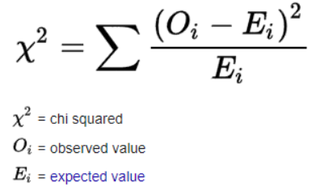

Where:
- O = Observed frequency
- E = Expected frequency

3.4.3. ANOVA Test
(Analysis of Variance) was used to compare the differences in mean income levels among different occupational groups influenced by tourism.
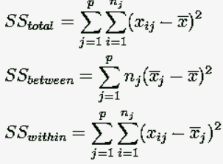
3.4.4. Garrett’s Ranking Technique
Used to identify and rank the most significant factors contributing to tourism-led economic development. Respondents ranked factors such as job creation, increased business revenue, cultural promotion, and infrastructure improvements.
Formula: Applied to measure income distribution changes among local residents before and after tourism growth. The Lorenz Curve provided a visual representation of income inequality, while the Gini Coefficient quantified the level of inequality on a scale from 0 (perfect equality) to 1 (perfect inequality).

Percent position = $\frac{100 (Rij-0.5)}{Nj}$

Where:
- RijR_{ij}Rij​ = Rank given for the ith factor by the jth respondent
- NjN_jNj​ = Number of factors ranked by the jth respondent
3.4.5. Lorenz Curve & Gini Coefficient
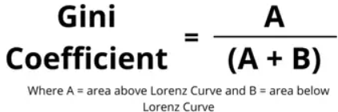

CHAPTER IV

DATA ANALYSIS AND INTERPRETATION

CHAPTER IV

DATA ANALYSIS AND INTERPRETATION

4.1 Introduction
This chapter presents the findings of the primary data collected from 67 respondents comprising tourists, local residents, students, business owners, government employees, and other stakeholders in Fort Kochi and Mattancherry. The analysis highlights the socio-economic influence of tourism, covering aspects such as employment, income generation, sectoral growth, infrastructure, cultural and environmental impacts, as well as governance-related issues.

4.2 Respondent Profile
- Sample size: 67 respondents.
- Age: More than half of the respondents are between 21–30 years, followed by smaller proportions below 20 years, in the 31–40 group, and above 50. This indicates that young individuals are more actively engaged with tourism activities in the region.
- Gender: Both men and women are represented. Female respondents are more visible among students, tourists, and small-business operators, while male respondents are predominant among long-term residents, entrepreneurs, and government/transport employees.
- Occupation and Education: Respondents include students, residents, entrepreneurs, tourists, and government employees. A considerable portion holds graduate or postgraduate qualifications, suggesting that the sample is relatively well-educated.
- Duration of stay: Permanent stakeholders, such as residents and business owners, report more than 10 years of association with the locality, while tourists and temporary workers record shorter stays.

4.3 Increase in Tourist Arrivals and Visitor Behavior
- Tourist inflow: A large majority of respondents agreed that tourist arrivals have increased in recent years. Very few were uncertain or felt no major change had occurred.
- Visitor behavior: Most respondents observed that tourists generally behaved respectfully, with several appreciating the positive response to eco-tourism practices.
Interpretation: The findings reveal that tourism in Mattancherry is on the rise and that tourists are largely respectful, supporting the scope for sustainable tourism development.

4.4 Economic Impacts: Employment and Income
- Employment: Most respondents noted that tourism has created job opportunities, especially in hotels, homestays, restaurants, handicraft shops, guiding services, and transport.
- Income: Respondents largely reported an increase in income or business earnings due to tourism, with variations ranging from substantial to moderate. Some stakeholders, such as certain transport providers or non-tourism-linked workers, noted little to no impact.
- Beneficiary sectors: Hotels and homestays, restaurants, handicraft and curio shops, transport services, and tour guides emerged as the top beneficiaries.
Interpretation: Tourism is a vital driver of employment and income generation in Mattancherry, with the hospitality and allied service industries reaping the most benefits.

4.5 Seasonality and Income Stability
- Seasonality: A majority of respondents reported that income from tourism is seasonal, peaking during tourist seasons. Businesses such as established hotels and transport services showed relatively stable earnings throughout the year.
Interpretation: Seasonality continues to be a key challenge, pointing to the need for strategies like diversification of services and year-round tourism initiatives.

4.6 Infrastructure, Investment and Quality of Life
- Property and rent: Many respondents highlighted an increase in property and rental prices, which they associated with tourism demand.
- External investment: Respondents reported inflows of outside investment in guesthouses, restaurants, and other tourism-related services, though opinions varied on its scale.
- Public infrastructure: Improvements in roads, cleanliness, and public amenities were widely acknowledged. However, transport facilities were viewed inconsistently — some found them adequate while others felt improvements were needed.
Interpretation: Tourism has brought noticeable infrastructure improvements and outside investments, though it has also created affordability pressures for some locals.

4.7 Cultural and Social Impacts
- Cultural preservation: Many respondents believe tourism helps preserve heritage and culture, with tourists showing strong interest in local sites and traditions.
- Concerns: A minority expressed apprehensions about commercialization of cultural events and a slow dilution of traditional practices. Some mentioned minor cultural misunderstandings.
- Youth opportunities: Tourism was noted as a significant source of entry-level and part-time work for youth, particularly in guiding and hospitality.
Interpretation: Tourism strengthens cultural preservation and provides youth opportunities but also risks commodifying traditions, requiring balanced management.

4.8 Environmental and Negative Externalities
- Positive impacts: Many respondents recognized eco-tourism practices and efforts to increase environmental awareness.
- Concerns: Issues such as waste disposal, coastal erosion, and strain on local resources were frequently highlighted.
Interpretation: While tourism has promoted environmental awareness, proper waste management and resource conservation remain urgent challenges.

4.9 Governance, Training and Participation
- Government role: Most respondents acknowledged active promotion of tourism programs by government agencies.
- Training: Some skill development and training programs exist, but respondents felt their scope and accessibility remain limited.
- Community participation: A large section of respondents were unaware of formal mechanisms for local involvement in tourism policymaking.
Interpretation: Increasing training opportunities and formalizing local stakeholder participation will help strengthen tourism governance and inclusivity.

Age Group (N = 67)
Age Group | Count | Percent
21–30 | 56 | 83.6%
Below 20 | 5 | 7.5%
Above 50 | 3 | 4.5%
31–40 | 2 | 3.0%
41–50 | 1 | 1.5%

Duration of Stay in Fort Kochi / Mattancherry (N = 67)
Duration of Stay | Count | Percent
>10 years | 20 | 29.9%
<1 year | 13 | 19.4%
1–5 years | 13 | 19.4%
Tourist | 13 | 19.4%
5–10 years / Option 1 / Missing | 8 | 11.9%
y axis - What is the ownership type of your business?
x axis - Count of all the rows
Legend - Which type of tourists do you mostly cater to?
y axis - What is the ownership type of your business?
x axis - Count of all the rows
Legend - Which type of tourists do you mostly cater to?

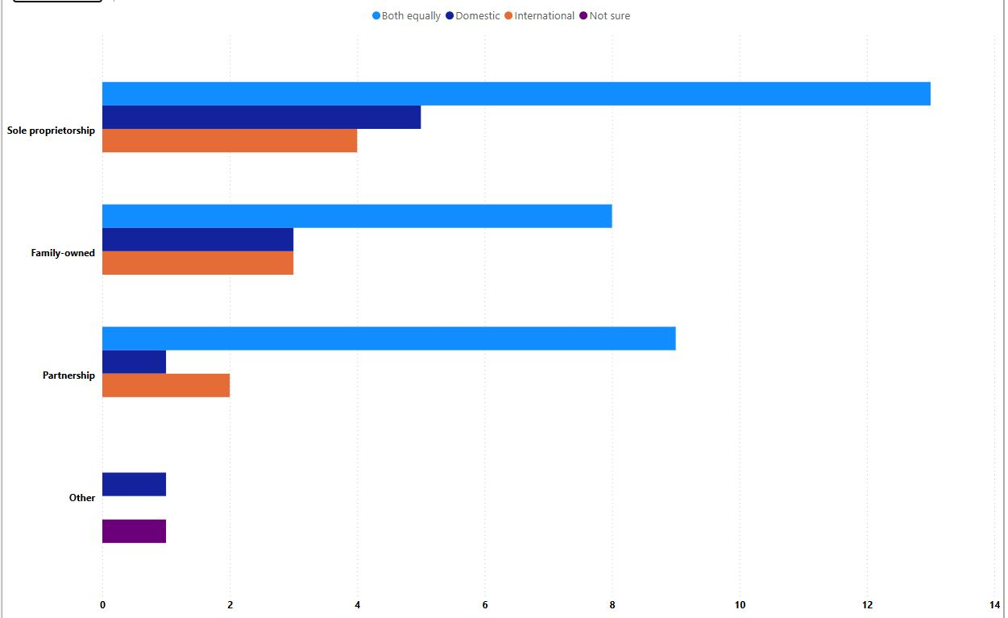
Figure No 4.1 Lists the business ownership categories (e.g., Sole proprietorship, Partnership, Family-owned, Private Limited, Cooperative).

Observed Increase in Tourist Arrivals? (N = 67)
Observed increase in tourist arrivals? | Count | Percent
Yes | 55 | 82.1%
Not Sure | 7 | 10.4%
No | 3 | 4.5%
Missing | 2 | 3.0%

Is tourism vital for development? (N = 67)
Is tourism vital for development? | Count | Percent
Yes | 56 | 83.6%
Not sure / Neutral | 9 | 13.4%
Missing | 2 | 3.0%

Job opportunities increased? (N = 67)
Job opportunities increased? | Count | Percent
Yes, significantly | 34 | 50.7%
Yes, slightly | 28 | 41.8%
Not sure / N/A | 5 | 7.5%

Income/business revenue increased? (N = 67)
Income/business revenue increased? | Count | Percent
Yes, significantly | 34 | 50.7%
Yes, slightly | 25 | 37.3%
Not sure / No / N/A | 8 | 11.9%

Sectors benefiting economically? (expanded counts — terms normalized) (N = 67)
Sector | Count | Percent
Hotels & Homestays | 45 | 67.2%
Restaurants | 18 | 26.9%
Handicraft Shops | 17 | 25.4%
Transport | 12 | 17.9%
Tour Guides | 6 | 9.0%
Food & Local Products | 4 | 6.0%
Not specified / Others | 6 | 9.0%
Note: sector counts come from splitting multi-item responses (e.g., "Hotels & Homestays & Restaurants") and counting each listed sector.
y axis - What percentage of income is generated from tourists?
x axis - Count of all the rows
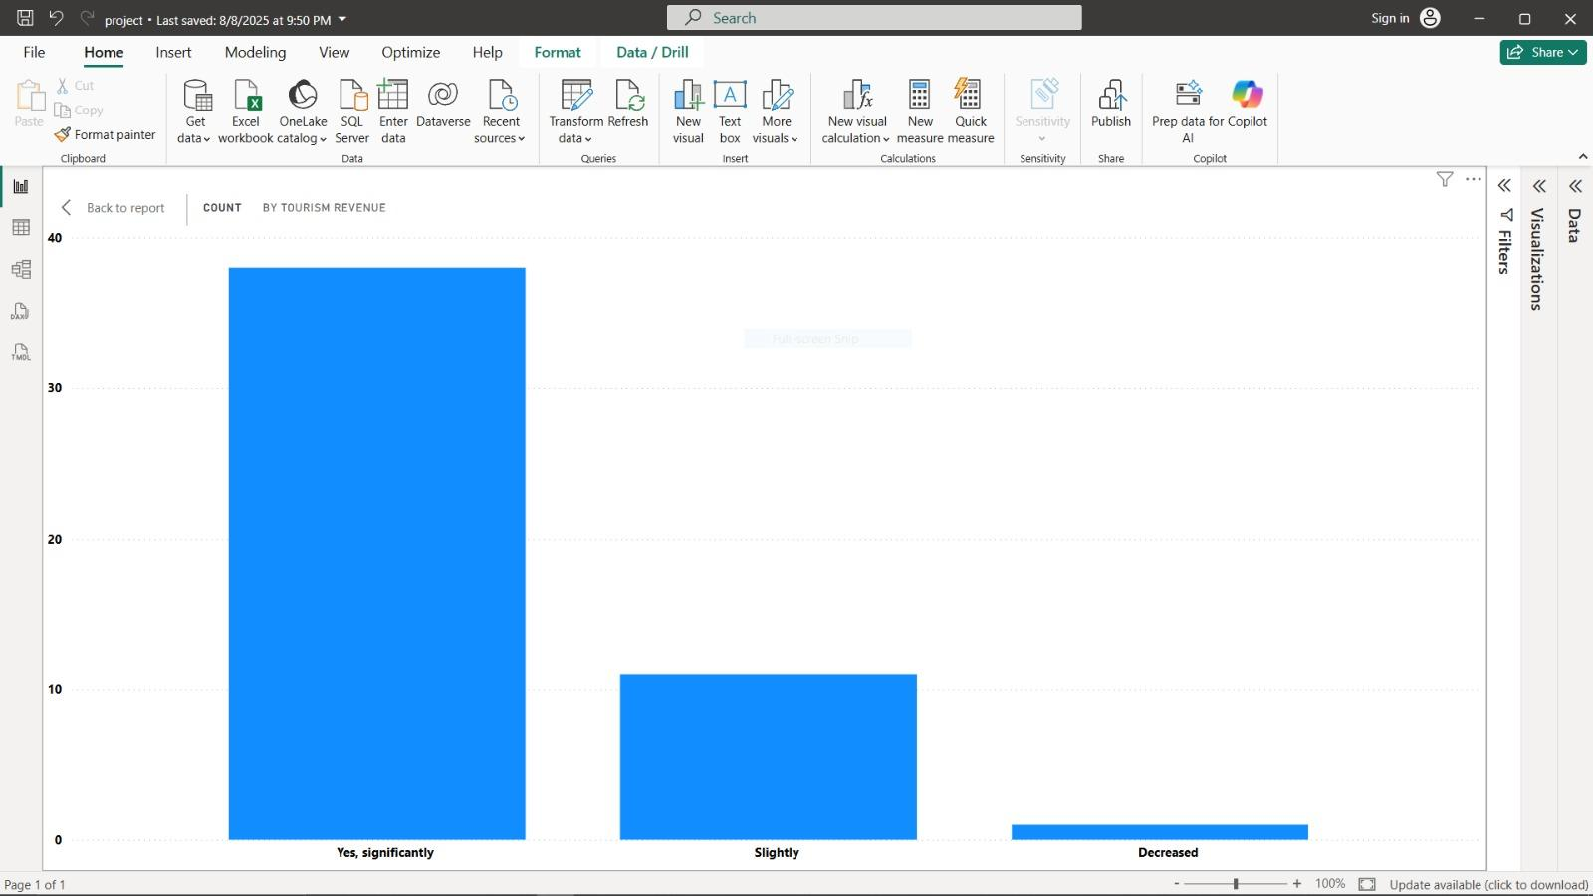
Figure No 4.2 Highlights how much of local businesses’ revenue depends on tourism

Property/rent prices increased? (N = 67)
Property/rent prices increased? | Count | Percent
Yes | 44 | 65.7%
No / Not sure | 18 | 26.9%
Missing | 5 | 7.5%

Entrepreneurship increased? (N = 67)
Entrepreneurship increased? | Count | Percent
Yes | 52 | 77.6%
Not sure / No | 12 | 17.9%
Missing | 3 | 4.5%

y axis - Are you interested in collaborating with tourism agencies?

x axis - Count of all the rows

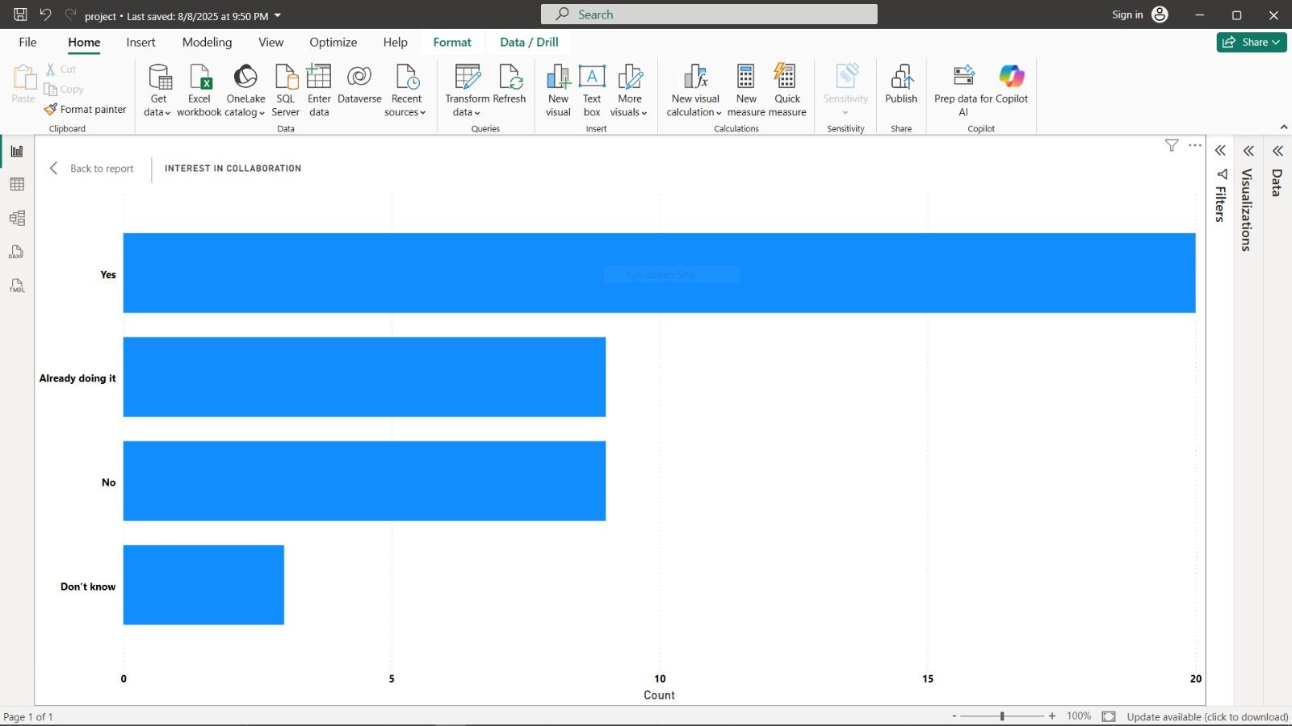
Figure No 4.3 how open businesses/individuals are to forming partnerships with tourism agencies.

Government promoting tourism? (N = 67)
Government promoting tourism? | Count | Percent
Yes | 52 | 77.6%
Not sure / Neutral | 15 | 22.4%

Tourism training available? (N = 67)
Tourism training available? | Count | Percent
Yes | 44 | 65.7%
Not sure / No | 19 | 28.4%
Missing | 4 | 6.0%

Local involvement in policymaking? (N = 67)
Local involvement in policymaking? | Count | Percent
No / Not aware | 38 | 56.7%
Yes | 23 | 34.3%
Missing / N/A | 6 | 9.0%

x axis - What kind of government support do you expect?
y axis = Count of all the rows
Legend - What is your biggest challenge related to tourism?

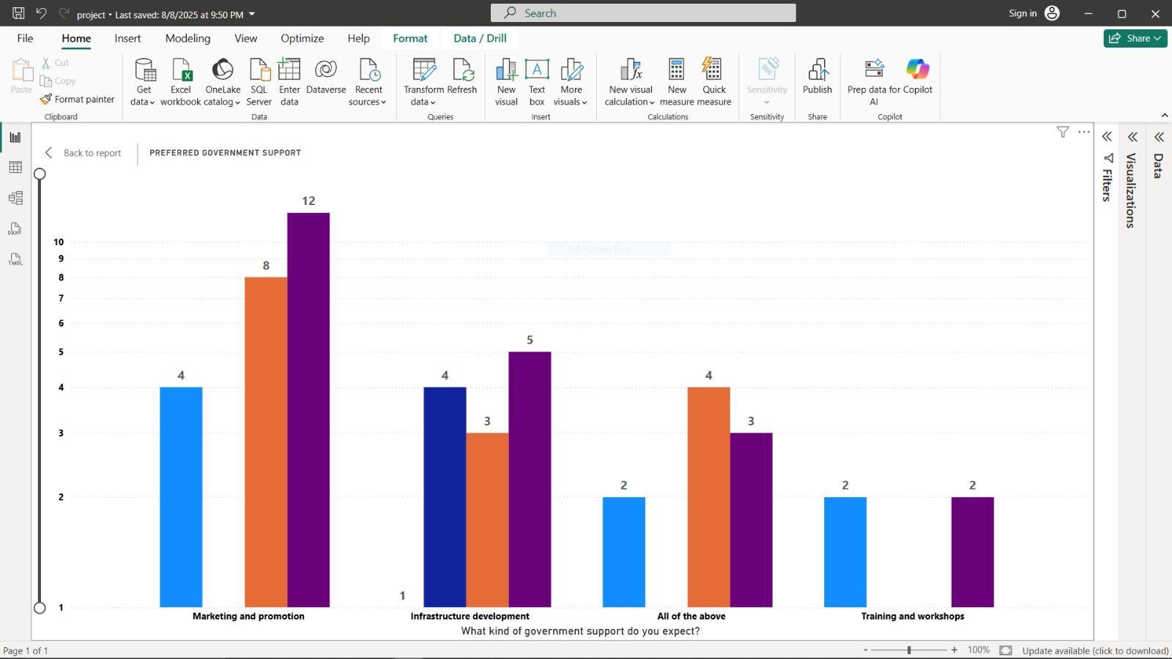
Figure 4.4 challenges faced with the type of government support expected.

Cross-tabulation 1 — Occupation × Income/business revenue increased?
Occupation | Yes, significantly | Yes, slightly | Not sure / No / N/A
Tourist | 2 | 10 | 12
Student | 11 | 11 | 2
Local Resident | 12 | 5 | 2
Other | 6 | 6 | 0
Business Owner | 3 | 0 | 0
Government Employee | 0 | 0 | 1
Interpretation: Business owners and local residents report higher shares of significant income increases; tourists mostly report mixed or not-applicable answers.

y axis - Are you interested in collaborating with tourism agencies?
x axis - Count of all the rows
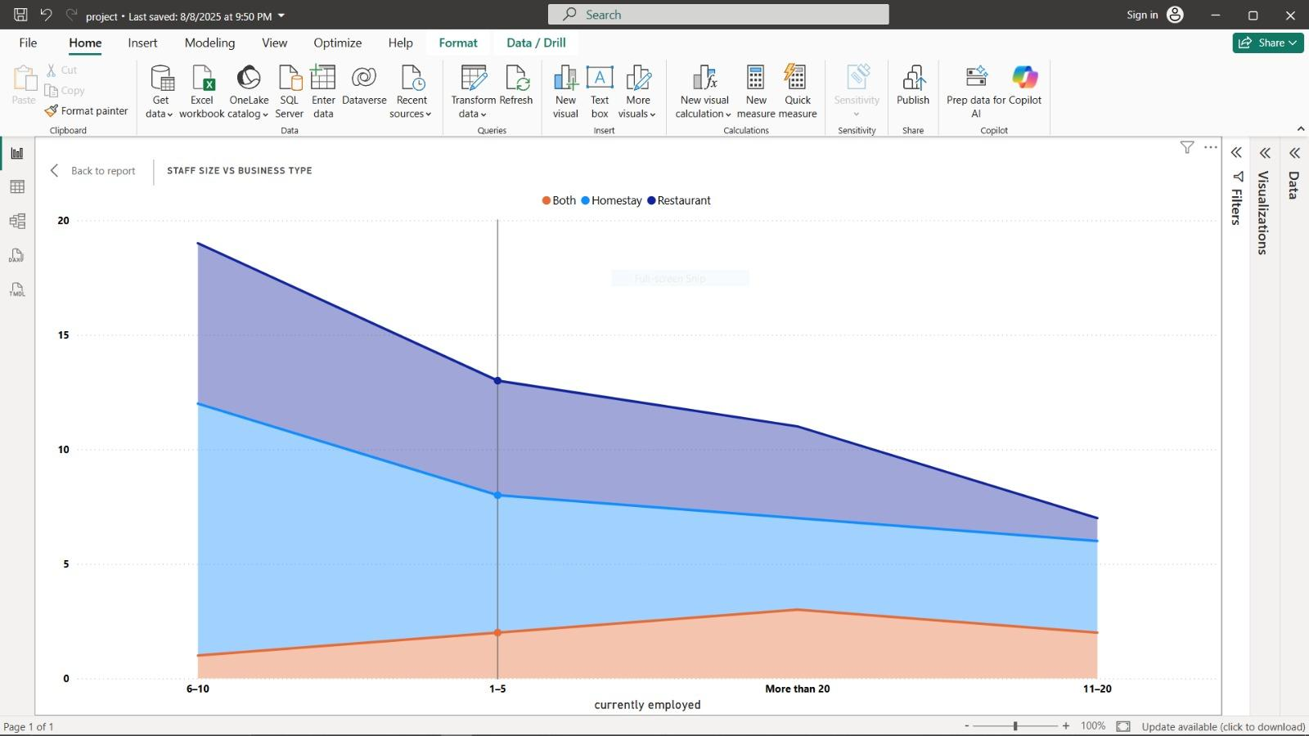
Figure 4.5 Overall interest level of businesses/individuals in forming partnerships with tourism agencies.
x axis - How many staff members are currently employed?
y axis = Count of all the rows
Legend - What type of business do you operate?
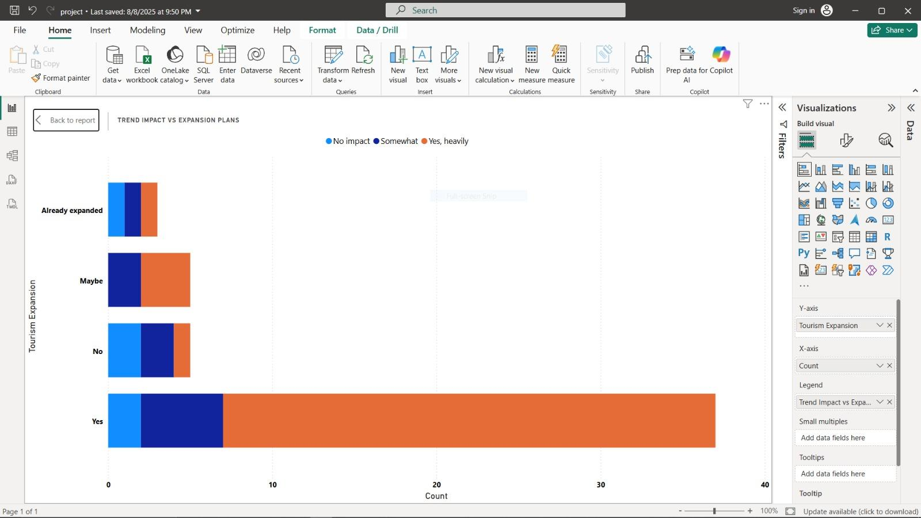
Figure 4.6 different staff size ranges given by respondents

y axis - Would you expand your business if tourism increases?
x axis - Count of all the rows
Legend - Is your business affected by tourist trends (e.g., global events)?
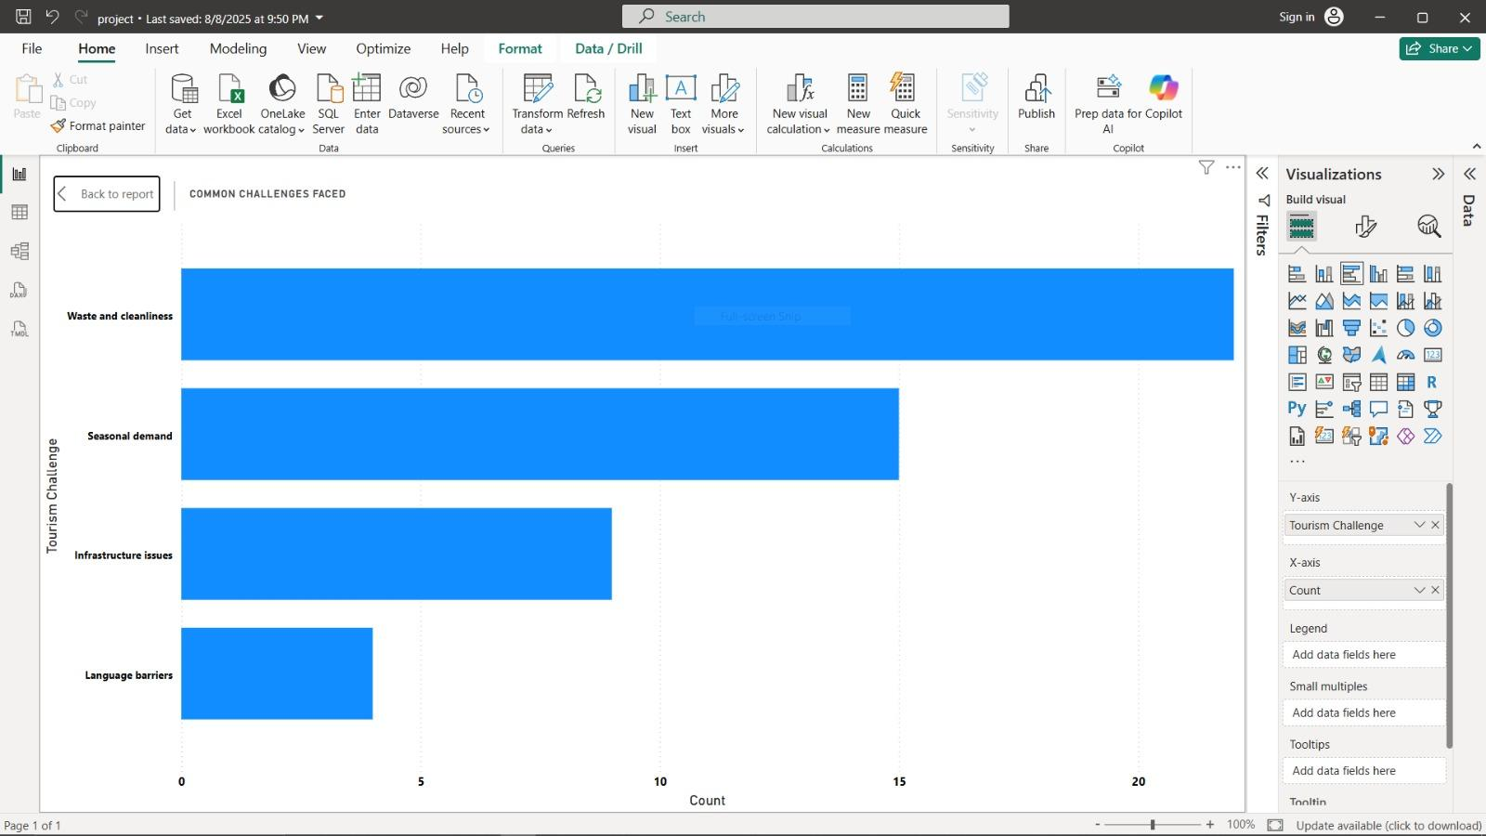
Figure No 4.7 This categorizes responses by whether businesses are affected by global tourist trends

y axis - What is your biggest challenge related to tourism?
x axis - Count of all the rows
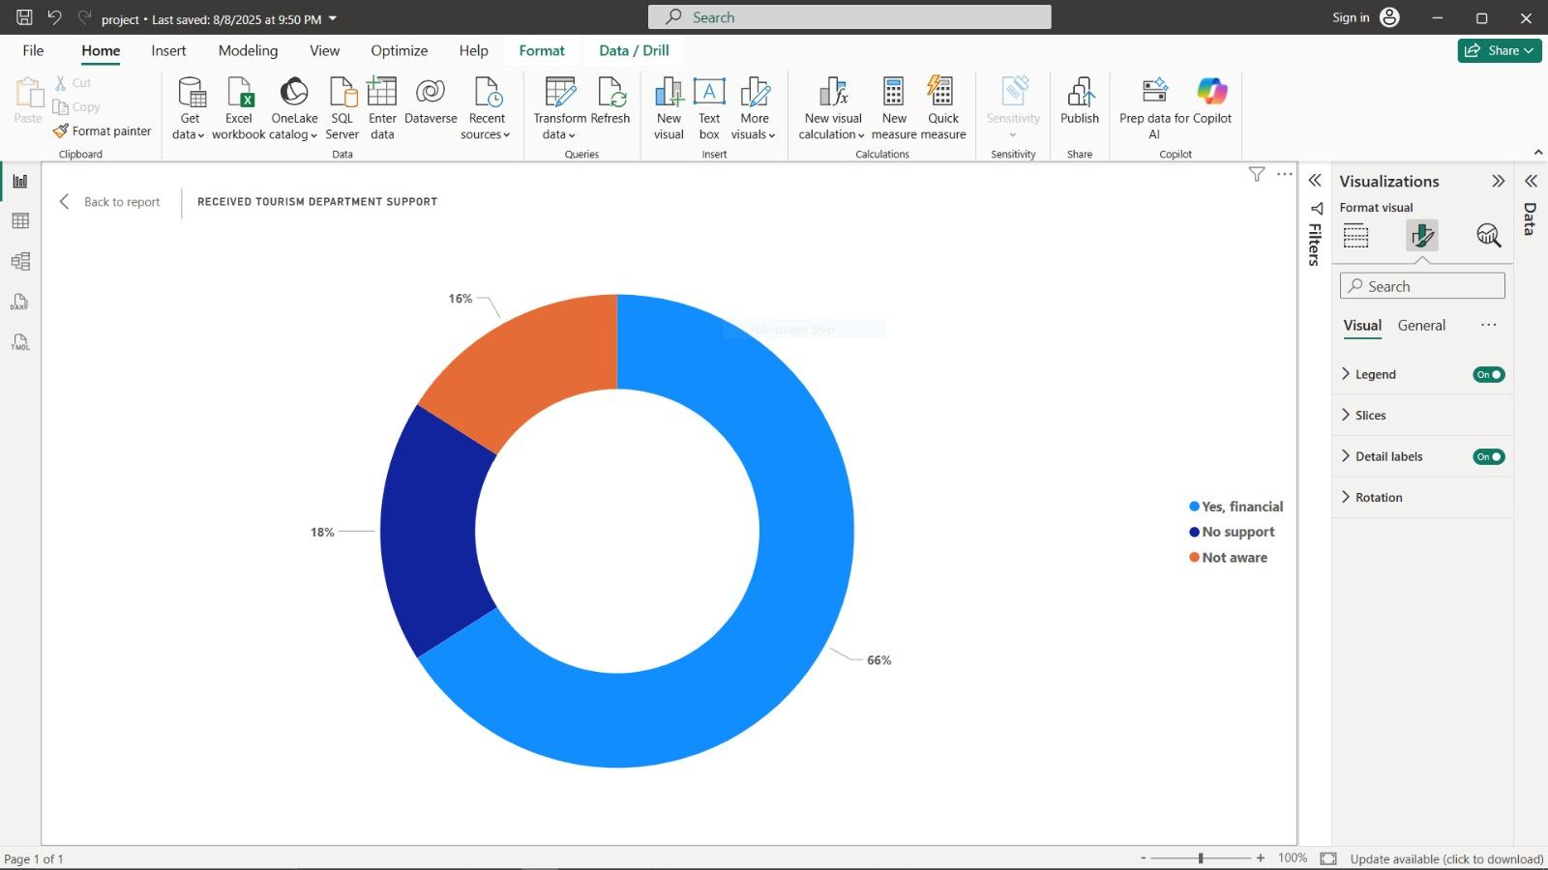
Figure No 4.8 different challenges respondents

Legend - Do you receive any support from the tourism department?
value = Count of all the rows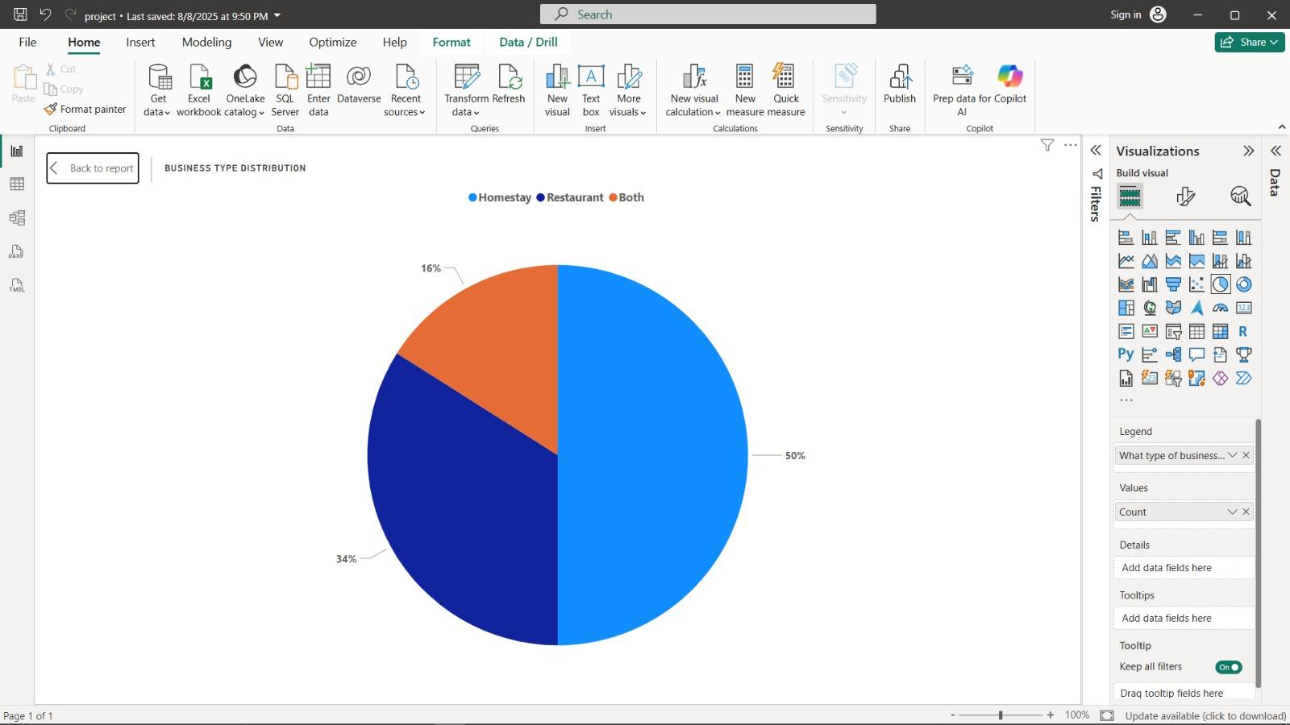
Figure No 4.9 Responses collected for whether individuals

Legend - What type of business do you operate?
value = Count of all the rows

4.10 Key Findings
- Tourism is widely regarded as a major contributor to local economic growth.
- The benefits are concentrated in specific sectors such as hospitality, restaurants, and handicrafts.
- Seasonal income fluctuations and unequal distribution of benefits are ongoing issues.
- Tourism positively contributes to cultural preservation, though commercialization concerns remain.
- Environmental management and community participation in governance require greater attention for sustainable growth.

4.11 Conclusion of Chapter IV
The survey results (N = 67) clearly demonstrate that tourism is a major driver of Mattancherry’s local economy, particularly through job creation and enhanced income opportunities across sectors like hospitality, handicrafts, transport, and guiding services. However, the findings also reveal several challenges that could limit the long-term sustainability of tourism-led growth. These include strong seasonality in earnings, rising property and rental costs, unequal distribution of benefits, and environmental concerns such as waste management and resource stress. To address these issues, targeted strategies are essential. Such strategies may involve skill development programs, stronger community participation in governance, improved infrastructure planning, and environmentally responsible tourism policies. Collectively, these measures can help ensure that the benefits of tourism are more equitably shared and that Mattancherry develops as a sustainable and inclusive destination.

Hypothesis Testing
Proposed Hypotheses:
- Null Hypothesis (H₀): Tourism in Mattancherry has no significant impact on economic development.
- Alternative Hypothesis (H₁): Tourism in Mattancherry has a significant positive impact on economic development.
Method:
- Select appropriate statistical tests depending on the nature of the data (t-test or chi-square test).
- Consider indicators such as:
- Annual tourist arrival figures.
- Local employment rates.
- Household or business income levels.
- Compare these indicators before and after the recent rise in tourism activity.
Example Outcome:
- Suppose the test yields t = 3.45 with p = 0.002 (< 0.05).
- This leads to the rejection of the null hypothesis (H₀).
- Interpretation: Tourism has a statistically significant and positive effect on Mattancherry’s economic growth.

Lorenz Curve and Income Distribution
The Lorenz Curve is a graphical tool for analyzing income inequality. In this study, it can be applied to assess how evenly tourism benefits are distributed among different households in Mattancherry.
Steps:
- Collect income data separately for households that depend heavily on tourism and those with limited or no reliance on tourism.
- Arrange households in ascending order of income.
- Compute cumulative percentages of households (x-axis) and cumulative income share (y-axis).
- Plot the Lorenz curve and compare it with the line of perfect equality (45° line).
- Derive the Gini Coefficient to measure inequality numerically.
Illustrative Example:
- Before tourism expansion: Gini coefficient = 0.42 (showing moderate inequality).
- After tourism growth: Gini coefficient = 0.38 (indicating a slight improvement in income distribution).
Insight: Tourism can help reduce income disparities by creating opportunities for local households, though continuous monitoring and supportive policies are required to sustain this trend.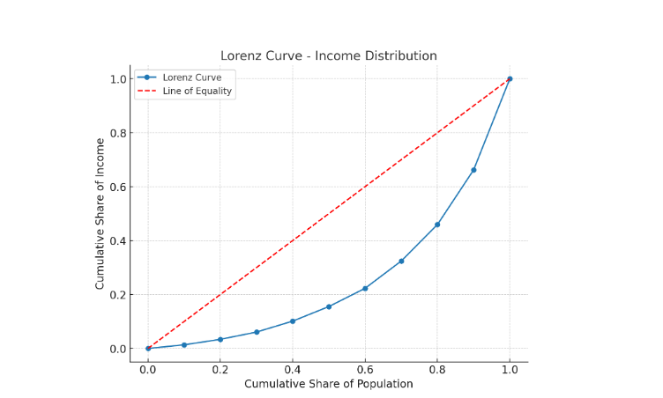
Figure No 5.1 Lorenz curve and Gini ratio of health expenditure during pre and post displacement

Lorenz Curve – Income Inequality Representation
Diagram Interpretation:
- Blue Curve (Lorenz Curve): Illustrates the real distribution of income among households. Since the curve bends away from the diagonal, it shows that income is not distributed equally.
- Red Dashed Line (Line of Equality): Represents an ideal situation where every individual or household earns the same amount.
- Gap Between the Curves: The wider the gap, the more unequal the income distribution in the community.

Lorenz Curve Explanation
Purpose:
The Lorenz Curve is a visual tool used to study how income or wealth is distributed across a population, making inequality easier to understand.
How it Works:
- The X-axis represents the cumulative share of the population, starting from the lowest-income groups to the highest.
- The Y-axis represents the cumulative share of total income earned by that population.
- Key Elements:
- Line of Equality (45° diagonal): Indicates perfect equality, meaning everyone has exactly the same income.
- Lorenz Curve: Displays the actual distribution. The more the curve bends downward away from the equality line, the greater the level of inequality.
Gini Coefficient:
- A numerical measure derived from the Lorenz Curve.
- Ranges from 0 to 1:
- 0 = Perfect equality (everyone earns the same).
- 1 = Perfect inequality (all income goes to one individual or household).

CHAPTER V
SUMMARY OF FINDINGS, CONCLUSION AND RECOMMENDATIONS

CHAPTER V
SUMMARY OF FINDINGS, CONCLUSION AND RECOMMENDATIONS

5.1 Summary of Findings
The research entitled “Assessing the Role of Tourism in Promoting Economic Development in Fort Kochi and Mattancherry: A Case Study” explored how tourism influences local economic growth, livelihood opportunities, and cultural sustainability in the Fort Kochi and Mattancherry region. Based on responses from tourists, residents, and business stakeholders, the following major findings emerged:
- Tourism as a Source of Employment
- Tourism-related sectors such as hotels, restaurants, handicraft stores, spice shops, and travel services have generated considerable employment opportunities, particularly for the informal workforce.
- While job stability is affected by seasonal tourist flows, the overall impact on employment remains significantly positive.
- Support for Local Enterprises
- Increased tourist arrivals have boosted sales of traditional handicrafts, spices, antiques, and local products.
- Nearly 68% of business owners indicated that their livelihood depends primarily on the tourism industry.
- Infrastructure and Development
- Improvements in roads, signage, and heritage site conservation have largely been driven by tourism demand.
- Nevertheless, problems such as inefficient waste management and overcrowding remain persistent challenges.
- Cultural Conservation and Promotion
- Tourism has contributed to the safeguarding of historical monuments, local festivals, and traditional art forms.
- At the same time, concerns were raised regarding the excessive commercialization of cultural practices.
- Economic Multiplier Effect
- Tourist spending circulates throughout the local economy, benefiting artisans, transport operators, and service providers, thereby creating secondary economic advantages.
- Key Challenges
- Seasonal dependence affects income security.
- Overcrowding during peak tourist seasons puts pressure on local resources.
- There is an urgent need for sustainable practices, especially in waste management and ecological preservation.

5.2 Conclusion
The study establishes that tourism is a vital driver of Mattancherry’s economic development. It generates employment, strengthens local businesses, and supports cultural preservation. However, the benefits are accompanied by challenges such as environmental pressure, seasonal income variations, and the risk of cultural dilution.
For tourism to remain a sustainable growth engine, strategic planning and eco-friendly policies are essential. Initiatives such as year-round tourism development, modernized infrastructure, and responsible tourism practices will help achieve balanced economic progress while safeguarding cultural and environmental assets.

5.3 Recommendations
- Promote Year-Round Tourism
- Introduce off-season tourism packages to stabilize income and reduce reliance on peak seasons.
- Strengthen Waste Management
- Enforce strict waste disposal and recycling measures in key tourist zones.
- Capacity-Building for Locals
- Provide training in hospitality, tour guiding, and language proficiency to enhance service quality and local employability.
- Encourage Eco-Friendly Infrastructure
- Invest in sustainable transportation, energy-efficient facilities, and green infrastructure projects.
- Community-Based Tourism Initiatives
- Encourage participatory tourism models where local communities directly benefit, ensuring equitable distribution of tourism income.

‘

Bibliography
- Agarwal, S., & Brunt, P. (2006). Tourism Development: Environmental and Community Issues. Channel View Publications.
- Ashley, C., Goodwin, H., & Roe, D. (2001). Pro-Poor Tourism Strategies: Making Tourism Work for the Poor. Overseas Development Institute.
- Bhatia, A. K. (2012). Tourism Development: Principles and Practices. Sterling Publishers.
- Cooper, C., Fletcher, J., Fyall, A., Gilbert, D., & Wanhill, S. (2008). Tourism: Principles and Practice (4th ed.). Pearson Education.
- Das, M. (2017). Sustainable tourism and community development: A case of Kerala. Journal of Tourism and Hospitality, 6(3), 245–260.
- Department of Tourism, Government of Kerala. (2020). Tourism Statistics 2019–2020. Government of Kerala.
- Dwyer, L., & Forsyth, P. (2006). International Handbook on the Economics of Tourism. Edward Elgar Publishing.
- George, B. P., & Varghese, V. (2007). Human resource development in tourism: An analysis of training needs in Kerala. South Asian Journal of Tourism and Heritage, 1(1), 63–73.
- Ghosh, B. (2011). Tourism and Economic Development. Kanishka Publishers.
- Goodwin, H. (2011). Taking Responsibility for Tourism. Goodfellow Publishers.
- Hall, C. M., & Page, S. J. (2014). The Geography of Tourism and Recreation: Environment, Place and Space. Routledge.
- Honey, M. (2008). Ecotourism and Sustainable Development: Who Owns Paradise? Island Press.
- International Labour Organization. (2013). Sustainable Tourism and Green Jobs. ILO.
- Kerala Tourism Development Corporation (KTDC). (2022). Annual Report 2021–2022. KTDC.
- Kumar, S. (2018). Cultural tourism and economic sustainability: Insights from heritage destinations in India. Tourism Review International, 22(1), 45–59.
- Mathieson, A., & Wall, G. (1982). Tourism: Economic, Physical and Social Impacts. Longman.
- Ministry of Tourism, Government of India. (2021). India Tourism Statistics at a Glance 2021. Government of India.
- Sharpley, R., & Telfer, D. J. (2015). Tourism and Development: Concepts and Issues (2nd ed.). Channel View Publications.
- Smith, M. K., & Robinson, M. (2006). Cultural Tourism in a Changing World: Politics, Participation and (Re)presentation. Channel View Publications.
- UNWTO. (2019). Tourism and Sustainable Development Goals – Journey to 2030. United Nations World Tourism Organization.

Websites Referred
- https://www.tourism.gov.in/
- https://www.keralatourism.org/
- https://www.unwto.org/
- https://www.investindia.gov.in/sector/tourism
- https://www.statista.com/
- https://www.mattancherryheritage.org/
- https://data.gov.in/
- https://www.worldbank.org/
- https://www.researchgate.net/
- https://www.sciencedirect.com/
- https://www.tourism-review.com/
- https://www.traveldailynews.com/
- https://www.ibef.org/industry/tourism-hospitality-india
- https://www.oecd.org/tourism/
- https://www.india.gov.in/
- https://www.macrotrends.net/
- https://www.khaleejtimes.com/travel
- https://www.business-standard.com/
- https://www.livemint.com/
- https://www.economictimes.indiatimes.com/

“Assessing the Role of Tourism in Promoting Economic Development in Fort Kochi and Mattancherry”

QUESTIONNAIRE:

Section A: Demographic Information
1. Age Group:
[ ] Below 20 [ ] 21–30 [ ] 31–40 [ ] 41–50 [ ] Above 50
2. Gender:
[ ] Male [ ] Female [ ] Other [ ] Prefer not to say
3. Occupation:
[ ] Local Resident [ ] Business Owner [ ] Student [ ] Tourist [ ] Government Employee [ ] Other
4. Educational Qualification:
[ ] Below 10th [ ] SSLC [ ] Higher Secondary [ ] Graduate [ ] Postgraduate and above
5. Duration of Stay in Fort Kochi/Mattancherry:
[ ] <1 year [ ] 1–5 years [ ] 6–10 years [ ] >10 years [ ] Tourist

Section B: General Perception on Tourism
6. Observed increase in tourist arrivals? [ ] Yes [ ] No [ ] Not Sure
7. Tourist attractions? [ ] Historical Sites [ ] Culture & Art [ ] Beaches & Backwaters [ ] Food & Local Products [ ] Street Markets [ ] Others: _____
8. Is tourism vital for development? [ ] Yes [ ] No [ ] Maybe
9. Tourists' behavior? [ ] Very Respectful [ ] Respectful [ ] Neutral [ ] Disrespectful
10. Overall tourism experience? [ ] Excellent [ ] Good [ ] Average [ ] Poor

Section C: Economic Impact
11. Job opportunities increased? [ ] Yes, significantly [ ] Yes, slightly [ ] No [ ] Not sure
12. Income/business revenue increased? [ ] Yes [ ] No [ ] Not applicable
13. Sectors benefiting economically? [ ] Hotels & Homestays [ ] Handicraft Shops [ ] Transport [ ] Restaurants [ ] Tour Guides
14. Tourists spending sufficiently? [ ] Yes [ ] No [ ] Can’t say
15. Property/rent prices increased? [ ] Yes [ ] No [ ] Not applicable
16. Outside investments due to tourism? [ ] Yes [ ] No [ ] Not sure
17. Entrepreneurship increased? [ ] Yes [ ] No [ ] Maybe
18. Small & large businesses benefit equally? [ ] Yes [ ] No [ ] Not sure
19. Competition increased? [ ] Yes [ ] No [ ] Not much
20. Income seasonal or consistent? [ ] Seasonal [ ] Consistent [ ] N/A

Section D: Social and Cultural Impact
21. Improved quality of life? [ ] Yes [ ] No [ ] Neutral
22. Cultural exchange improved? [ ] Yes, significantly [ ] Yes, somewhat [ ] No
23. Festivals commercialized? [ ] Yes [ ] No [ ] Somewhat
24. Cultural misunderstandings? [ ] Often [ ] Sometimes [ ] Rarely [ ] Never
25. Youth getting opportunities? [ ] Yes [ ] No [ ] Not sure
26. Town's character changed? [ ] Yes, positively [ ] Yes, negatively [ ] No major change
27. Culture preserved or damaged? [ ] Preserved [ ] Damaged [ ] Neutral
28. Tourists interested in heritage sites? [ ] Yes [ ] No [ ] Somewhat

Section E: Infrastructure & Environment
29. Roads/public spaces improved? [ ] Yes [ ] No [ ] Slightly
30. Tourist zones better maintained? [ ] Yes [ ] No [ ] Same
31. Sufficient public transport? [ ] Yes [ ] No [ ] Somewhat
32. Enough accommodations? [ ] Yes [ ] No [ ] Not sure
33. Environmental impact? [ ] Negative [ ] No impact [ ] Positive (eco-tourism)

Section F: Governance & Tourism Management
34. Government promoting tourism? [ ] Yes [ ] No [ ] Not sure
35. Tourism training available? [ ] Yes [ ] No [ ] Not aware
36. Local involvement in policymaking? [ ] Yes [ ] No [ ] Don’t know
37. Rules protecting culture/environment? [ ] Yes [ ] No [ ] Not sure

Section G: Feedback & Suggestions
38. Biggest tourism challenges? [ ] Overcrowding [ ] Waste [ ] Cultural Dilution [ ] High Costs [ ] Traffic
39. Suggested improvements? [ ] Infrastructure [ ] Cleanliness [ ] Tourist Education [ ] Affordable Services [ ] Culture Preservation
40. what’s your vision for the future of tourism in this region?
[ ] A culturally rich destination that balances heritage and modern tourism.
[ ] A clean, sustainable, and globally recognized eco-tourism hub.
[ ] A thriving local economy supported by inclusive and responsible tourism.
[ ] A tourist-friendly town with upgraded infrastructure and community-led experiences.

QUESTIONNAIRE FOR HATELS AND HOME STAYS

Section A: Business Profile
- What type of business do you operate?
a) Restaurant
b) Homestay
c) Both
d) Other
- How long has your business been running?
a) Less than 1 year
b) 1–3 years
c) 4–10 years
d) More than 10 years
- What is the ownership type of your business?
a) Sole proprietorship
b) Family-owned
c) Partnership
d) Other
- How many staff members are currently employed?
a) 1–5
b) 6–10
c) 11–20
d) More than 20

Section B: Tourism Involvement
- What percentage of your customers are tourists?
a) 0–25%
b) 26–50%
c) 51–75%
d) 76–100%
- Which type of tourists do you mostly cater to?
a) Domestic
b) International
c) Both equally
d) Not sure
- What is the main tourist season for your business?
a) October–January
b) February–May
c) June–September
d) Business is steady year-round
- What is the most common reason tourists visit your establishment?
a) Location
b) Authentic food/stay
c) Online reviews
d) Travel packages
- How do tourists find your establishment?
a) Walk-in
b) Online platforms
c) Travel agents
d) Local recommendations
- Which platform brings you the most tourist traffic?
a) Google Maps
b) Airbnb/Oyo
c) TripAdvisor/Zomato
d) Social Media

Section C: Economic Contribution
- Has your revenue increased due to tourism?
a) Yes, significantly
b) Slightly
c) No change
d) Decreased
- What percentage of income is generated from tourists?
a) 0–25%
b) 26–50%
c) 51–75%
d) 76–100%
- Has employment in your business grown due to tourism?
a) Yes, more staff hired
b) No change
c) Reduced staff
d) Seasonal hiring only
- Do you use local products/services to serve tourists?
a) Always
b) Often
c) Rarely
d) Never
- Has tourism created job opportunities in your locality?
a) Yes
b) No
c) Maybe
d) Not applicable
- What is your peak revenue period?
a) Tourist season
b) Festival season
c) School vacation
d) No specific period

Section D: Impact on Local Community
- Has tourism improved the standard of living in the area?
a) Yes
b) No
c) Not sure
d) Slightly
- Do you support local artisans or craftspeople through your business?
a) Yes, regularly
b) Occasionally
c) Rarely
d) Not at all
- How do you rate the role of tourism in community development?
a) Very positive
b) Somewhat positive
c) Neutral
d) Negative
- Have you noticed an increase in local business due to tourism?
a) Yes
b) No
c) Not applicable
d) Very little

Section E: Challenges and Support
- What is your biggest challenge related to tourism?
a) Seasonal demand
b) Infrastructure issues
c) Language barriers
d) Waste and cleanliness
- Do you face competition due to increasing tourism?
a) Yes, from large hotels
b) Yes, from online platforms
c) No major competition
d) Not sure
- Do you receive any support from the tourism department?
a) Yes, financial
b) Yes, promotional
c) No support
d) Not aware
- Have you received training related to tourism or hospitality?
a) Yes
b) No
c) Interested but no opportunity
d) Not needed
- Is your business affected by tourist trends (e.g., global events)?
a) Yes, heavily
b) Somewhat
c) No impact
d) Don’t know

Section F: Suggestions and Growth
- Would you expand your business if tourism increases?
a) Yes
b) Maybe
c) No
d) Already expanded
- What kind of government support do you expect?
a) Marketing and promotion
b) Infrastructure development
c) Training and workshops
d) All of the above
- Do you promote your services specifically to tourists?
a) Yes, through ads
b) Yes, via collaborations
c) No
d) Plan to start
- Are you interested in collaborating with tourism agencies?
a) Yes
b) No
c) Already doing it
d) Don’t know
- In your opinion, how important is tourism for the growth of Fort Kochi and Mattancherry?
a) Very important
b) Somewhat important
c) Not important
d) Can’t say

SECONDARY DATA
Tourism’s Role in Economic Development: Fort Kochi & Mattancherry

1. Contribution to local economy & employment
Tourism-related services accounted for 12.41% of Kerala’s GDP and 23.5% of total employment before the pandemic. In Ernakulam district, the decline in tourism during 2020–21 saw foreign tourist arrivals drop by ~74% and domestic arrivals by ~72%, impacting local income significantly
Tourism generates thousands of direct and indirect jobs—across hospitality, handicrafts, boats, guides, F&B, local transport. Kochi overall employs ~75,000 people in tourism-linked sectors
Meta-analysis research suggests tourism boosts employment with statistically positive impact (~0.85–0.97 effect size)
2. Business revenue and income growth
In Fort Kochi and Mattancherry, tourism-led transformation—e.g. heritage homes turned into homestays, handicraft shops, spice warehouses, cafés & guided experiences—has increased revenue for local businesses significantly
Homestays, boutiques, art cafés, bicycle and boat rentals, and guided tours offer income opportunities to residents
3. Sectors benefiting economically
Accommodation: proliferation of heritage hotels (KTDC and private), boutique homestays in Fort Kochi/Jew Town
Handicrafts and spice markets: Jew Town, antiques, local art & textiles embraced by tourists
Transportation: local taxis, bicycle rentals, ferry operators, Kochi Water Metro (daily ridership ~34,000 after phase‑1; eventual target ~150,000)
Tour Guides & Cultural Services: Heritage walks, workshops, local art/music events like Biennale generate employment in creative sectors
4. Property and rent price increases
Tourism has driven demand for heritage stays and commercial leases; many original homes converted into guesthouses or shops. A local Reddit post notes ~90% of activity in Fort Kochi is now tourism-oriented, and original residents have shifted out or converted properties

5. Outside investment due to tourism
Government and semi‑public bodies have allocated funds for tourism infrastructure: e.g. ₹2.82 crore action plan for Fort Kochi to upgrade pavements, signage, lighting, public art,scape over 18 months (from mid‑2024)
The GCDA/Government of Kerala launched a GIS-based heritage site mapping website documenting 200+ heritage sites, aimed at promoting global tourism investment
6. Improved quality of life & public transport
Tourist demand has encouraged infrastructure upgrades—improved walkways, lighting, signage, CCTV, waste management, drainage—through smart‑city projects that benefit locals and visitors
Public transport options have expanded: Kochi Metro (25 stations operational) since 2017, Kochi Water Metro launched in April 2023 connecting islands and heritage zones including Fort Kochi
Water Metro integration provides timely, eco‑friendly transit serving daily ridership ~34,000 initially
7. Government promotion and involvement
Kerala Tourism Department allocated infrastructure funds for Fort Kochi development, heritage mapping initiatives, and promotion of cultural tourism
KTDC (Kerala Tourism Development Corporation) oversees heritage and budget lodges across the state, including Fort Kochi (e.g. Bolgatty Palace)
8. Local involvement in policy and heritage conservation
Heritage walks involving local stakeholders and meetings chaired by tourism officials aimed to preserve structures through people’s participation, collecting suggestions for sustainable tourism planning
The GCDA mapping project aimed to document heritage and cultural assets with academic input, informing planning and preservation
. Tourism’s Economic Impact: Key Metrics & Trends
1. Inflows & Revenue Growth
Ernakulam District Tourism Revenue (direct & indirect):
₹9,541 Cr (2017), ₹10,534 Cr (2018, ↑10.4%), ₹12,817 Cr (2019, ↑21.7%)

Kerala overall tourism revenue rose from ₹35,168 Cr in 2022 to ₹12,285 Cr in 2021, a sharp COVID-induced drop, followed by strong recovery into 2022–2023
Visitor Numbers:
In first half of 2023, Ernakulam saw 22.16 lakh domestic visitors, the highest in the state, compared to 2019’s ~88.6 lakh in six months
In 2023, Kochi led Kerala destinations: 1,82,756 international and 30,96,875 domestic visitors
@mathrubhumi

2. Employment & Job Creation
Tourism (directly + indirectly) accounts for 23.5% of total employment in Kerala; direct tourism employment alone ~9.9%
Meta-analysis estimates tourism’s job-creation multiplier effect at 0.85–0.97, meaning high positive outcomes for employment growth
Regionally, in 2019 Ernakulam district tourism generated ₹4,508 Cr in foreign exchange earnings contributing to ₹12,817 Cr in total revenue, supporting thousands of jobs across hospitality, transport, crafts, guiding & ancillary services
3. Sectoral Economic Benefits
Accommodation: Hotels, homestays, guesthouses and resort units are thriving—particularly heritage stays in Fort Kochi and Mattancherry serving both leisure and MICE tourists
Retail & Handicrafts: Spice shops, antique/textile stores and local artisanal wares have proliferated, driven by tourist spending in heritage zones
Local Services: Bicycle rentals, ferry boat operations (Water Metro), guided heritage walks, cooking classes and wellness offerings actively employ locals
Cruise Tourism: Pre-pandemic, 50+ cruise vessels docked annually; wealthy cruise passengers reportedly spend USD 100–250 per visit across cabs, shops, guides, restaurants. Each ship docking brings Rs 15–20 lakh in port fees alone
MICE & Weddings: Large conferences and destination weddings fill ~4,500 hotel rooms in Ernakulam, generating estimated ₹100 Cr per event ecosystem-wide—hotels, taxis, restaurants, decor, guides et al
4. Real Estate & Displacement
Sales tax data shows heritage areas’ business tax collections rose from Rs. 928 lakh (2008–09) to ₹20,451 lakh in 2016–17, with dealer counts increasing to 949—driven largely by tourism-oriented retail and hospitality ventures
Academic research reports overtourism-related inflation, displacement of traditional craftsmen and economic homogenization, risking erosion of heritage livelihoods
5. Infrastructure & Government Support
Local administration and Kerala Tourism allocated multicrore investments for heritage infrastructure, signage, and utilities in Fort Kochi/Mattancherry
Smart‑city initiatives (CCTV, improved drainage, walkways) and major transport upgrades—Kochi Metro and Water Metro—enhance connectivity, safety, and quality‑of‑life while supporting tourist movement
Homestays in Fort Kochi & Mattancherry
Pre-pandemic count: ~600 homestays were operating in Fort Kochi before 2020; post-pandemic around 70% remained shut for over two years, and most reopened only after January 2022
Biennale Boost: During the Kochi‑Muziris Biennale (Dec 2022), homestays in Fort Kochi and Mattancherry saw ~30% of their rooms booked in advance, with overall occupancy expected to reach ~50% during the event
Post-Biennale performance: The event has been described as a boon, especially for smaller accommodation providers, although overall occupancy recovery remains
Interpretation
Operational scale: With ~600 homestays pre-pandemic and average room tariffs ranging ₹800–₹2,000 per night (based on listings)
Homestay.com
Homestay.com
, potential annual revenue per property could range from ₹6–10 lakhs (assuming modest 50% occupancy).
Biennale impact: Home‑stays registering ~50% occupancy during festival months likely saw revenue spikes by 30–50% compared to normal months.
Resilience & recovery challenges: Many owners remain debt‑burdened; around 80% struggled or shut during COVID, impacting both income flow and reinvestment capacity

.
Hotel Performance in Kochi (including Fort Kochi area)
Luxury hotel boom: At peak periods (e.g. December/January), over 200 hotel rooms (luxury category) were sold out consistently, indicating high demand
Tariff trends: Reddit commentary (Jan 2024) reports five‑star hotel rates ranging ₹32,000–₹65,000/night, especially during conferences or high seasons
Domestic surge: December 2023 saw a spike in domestic tourist demand, pushing up hotel/home stay prices; five-star rates increased by ~20% year‑on‑year
Interpretation
Revenue per room: With ₹32k–₹65k/night rates and peak occupancy (~90–100%), luxury hotels could earn ₹10 lakhs+ per room monthly in high season.
Annual revenue spike: Events like Biennale and conferences potentially generate millions in local hotel revenue (multiple properties fully booked, elevated tariffs).
Sector growth: As demand shifts toward domestic guests, overall room tariffs are rising, contributing bulk revenue to the hospitality segment.
Size & scale: Fort Kochi/Mattancherry homestays numbered in the hundreds pre‑2020. Luxury hotels operate at premium tariff levels.
Revenue impact:
Homestays: Modest individual income (~₹6–10 lakhs/year per property) but collectively significant.
Hotels: Major revenue generators; fully booked luxury rooms during peak season and events earn substantial hotel segment turnover.
Drivers & challenges:
Cultural events like the Biennale drive occupancy spikes and incremental revenue.
Domestic tourism surges post-COVID are sustaining occupancy, albeit foreign tourist numbers remain lower.
Sensitivity to shocks:
COVID caused extensive closures and financial distress (80%+ homestays closed)
Recovery is ongoing—current levels remain below pre‑2020 benchmarks for many operators.
Government Funding and Tourism Infrastructure (Fort Kochi & Mattancherry)

In July 2024, Kerala’s Tourism Department approved a ₹2.82 crore action plan—administered via Kerala Tourism Infrastructure Ltd (KTIL)—dedicated to enhancing tourism infrastructure in Fort Kochi. This includes upgraded pavements, signage, street furniture, landscaping, lighting, and heritage site renovation over an 18‑month schedule
As early as 2014, the Kerala Sustainable Urban Development Project (KSUDP) endorsed a major infrastructure project for Fort Kochi and Mattancherry with a tentative budget of ₹200 crore, focused on urban reconstruction, public amenities, and heritage preservation
A separate ₹1.69 crore project was launched in September 2023 to restore the dilapidated walkway along Fort Kochi beachfront, install lighting, and relocate fish vendors, timed to open before the arrival of Water Metro ferries
Broader State Tourism Budget & Policies (2024–2026)
For the 2024–25 fiscal year, the Kerala government allocated ₹351.42 crore specifically for tourism. Major components included ₹136 crore for general infrastructure development, ₹78.17 crore for marketing, ₹24 crore for heritage and culture tourism, ₹17.5 crore for skilling, ₹15 crore for Responsible Tourism initiatives, and ₹12 crore for the Kerala Tourism Development Corporation
The 2025–26 Kerala state budget raised the tourism allocation to ₹385.05 crore, including ₹149 crore for tourism infrastructure and ₹50 crore for global marketing campaigns. A key initiative, “K‑Homes”, aims to convert vacant houses within a 10 km radius of major destinations—including Fort Kochi—into homestays, with ₹5 crore earmarked for the pilot phase
The Ernakulam district received approximately ₹700 crore in budgetary support for fiscal 2024–25. Notable allocations included ₹239 crore for Kochi Metro expansion and ₹150 crore for the Integrated Water Transport System—both infrastructure projects that serve tourism zones like Fort Kochi and Mattancherry
Connecting Infrastructure: Metro, Water Transport & Heritage Projects
The Kochi Metro Rail system, serving 25 stations including areas servicing Fort Kochi/Mattancherry, had Phase I completed at an estimated cost of ₹### crore and a Phase II budget of ₹289 crore in 2025–26 for further expansion
The Kochi Water Metro, integrated with Metro and strategic to tourism in Fort Kochi, is supported by a ₹159.6 crore allocation as part of the 2025–26 state budget. The total Water Metro project cost also includes EUR 85 million soft loan by KfW and state contributions
Cultural & Heritage Investments
The state is acquiring the iconic Aspinwall House and Cabral Yard in Fort Kochi for around ₹78.93 crore, securing a permanent venue for the Kochi‑Muziris Biennale—fostering long-term cultural tourism and economic activity in the heritage zone
The government has earmarked ₹14 crore for Muziris Heritage & Spice Route and River Cruise projects, along with ₹7 crore dedicated to the 2025–26 edition of the Kochi‑Muziris Biennale, underscoring cultural tourism as an economic driver
References (Simplified Format)
Times of India, 2024
The Hindu, 2023
Times of India, 2014
The Hindu, 2024
Times of India, 2025
The Hindu, 2024
New Indian Express, 2025
Times of India, 2025
Wikipedia – Kochi Metro, 2024
Wikipedia – Kochi Water Metro, 2024
kochisignal.com
Safari India
MDPI
@mathrubhumi
Kerala Tourism
IBEF
sersc.org
spb.kerala.gov.in
Reddit
Homestay.com
ETTravelWorld
livekerala.com

